Advanced Database Set-Up for DerbyNet
DerbyNet uses a database to store all the data for each event. In most situations, you should use the normal database set-up dialog, and just enter or select a database name, as described in the “Running a Race with DerbyNet” document. However, in some situations you may require more choices in using or creating your database. This document describes the use of these “advanced” database set-up options.
- Begin by following the set-up steps described in the “Running a Race with DerbyNet” document, until you get to the dialog for choosing or creating a database. Click the “Advanced” button. | 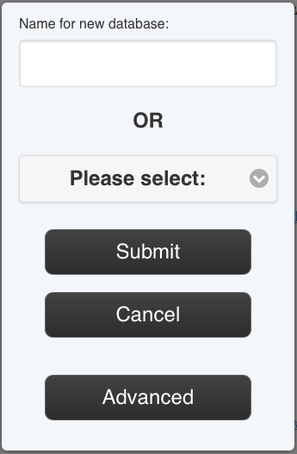
- The new dialog that appears offers several choices of database technology to use. The use of each choice is described in a separate section, below. | 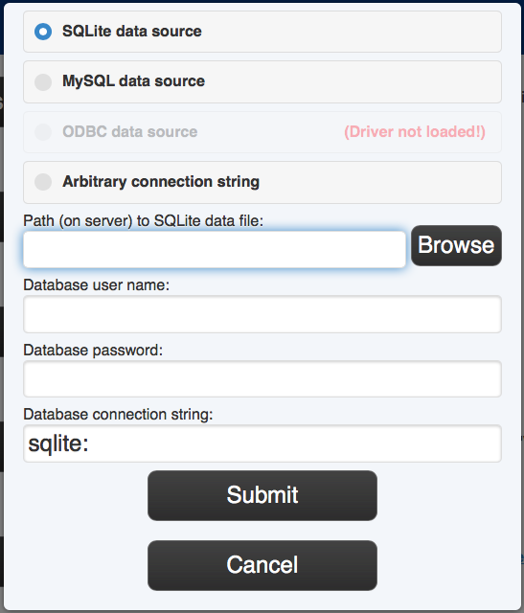

Using a SQLite Data Source
The most likely reason to choose this option is to gain access to a previously-created database file that happens not to have been stored in the expected location.
Choose “SQLite data source,” and enter the full path name (on the server) of your database file. For a SQLite database, you don't need a user name or password. Click the “Browse” button to choose a file location interactively.
The database file can be named anything you like, but it must be stored:
- On the same machine that hosts the DerbyNet web server.
- In a folder offering read and write access for the web server “user.” (Typically the web server runs as its own user, with the user name being something like “_www” or “www_data” or similar.)

Using an ODBC Data Source
The most likely reason to choose this option is to share a database with the Grand Prix Race Manager (GPRM) product by Lisano Enterprises. See the “Sharing a Database with GPRM” document for additional steps you must complete in order to make the GPRM database accessible as an ODBC data source.
From the “Advanced” database set-up dialog, choose “ODBC Data Source,” and enter the data source name (e.g., “GPRM”) in the space provided.
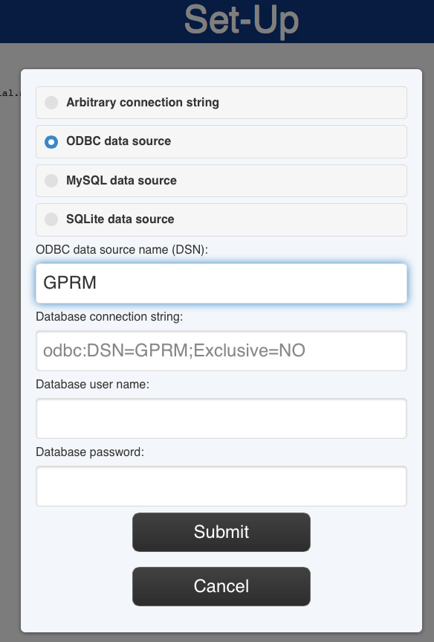
The connection string will get constructed as you type, and should look like:
odbc:DSN=GPRM;Exclusive=NO
where 'GPRM' is the name of the ODBC data source name you created.
You can leave the user name and password fields blank.

Do Not Initialize the Database Schema
Assuming your ODBC data source is an existing GPRM database, you should probably not initialize the schema – doing so will erase all the data that's in the database. If you haven't yet put any data in the database, then the schema initialization should have no effect.

Maybe Update the Database Schema
Similarly, the DerbyNet software should work well without the need to update the schema. (A schema update, as opposed to schema initialization, should preserve existing data in the database. However, DerbyNet should also function without the update.)

